**Security Analysis Report**

**We have Implemented diff Security Tests:**

We did our project analyzing tests on <https://observatory.mozilla.org/analyze/>

1. HTTP Observatory
2. TLS Observatory
3. SSH Observatory
4. Third Party Test

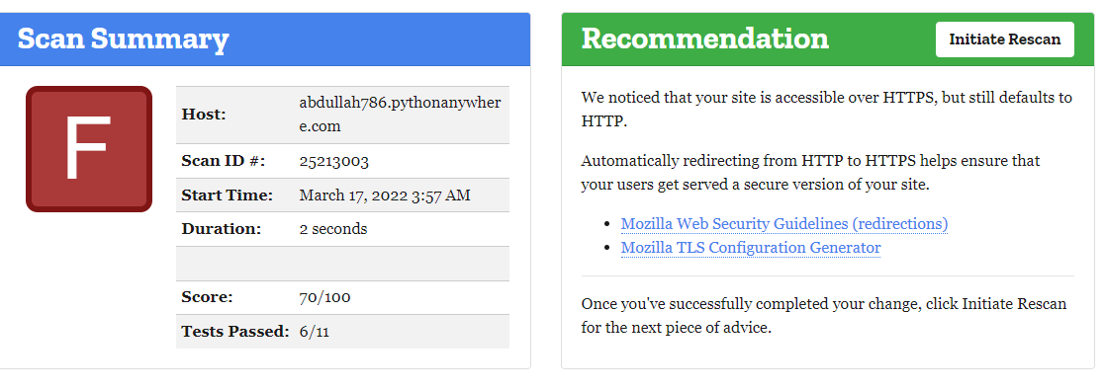**Note:** we are using free platform it’s on trial that’s why we have not connected any domain and any SSL certificate that’s why we are gaining some test fail.

**Security certificate:**

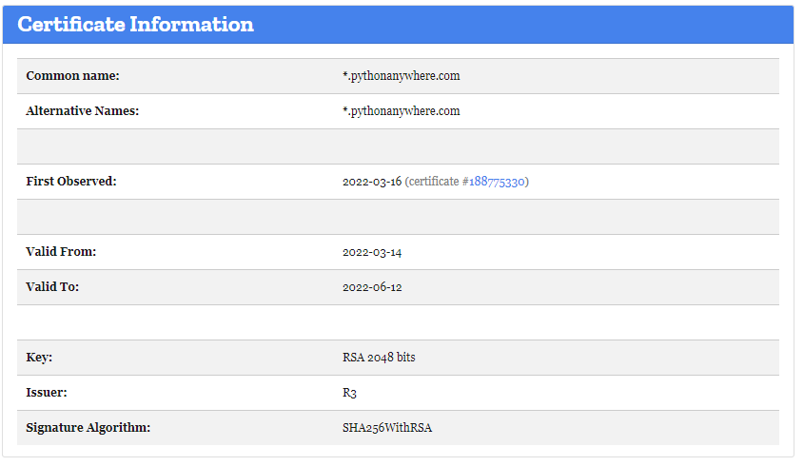 We did a security test on our website here’s the security test results we are checking identity, authenticity and reliability of a website or Web application is established. We are providing the security level by doing the security test this is how we can check the security tests results to general visitors, Internet service providers (ISPs) and Web servers.

**Raw Server Headers:**

In this test it’s checking our headers data like cookies work and sessions work which content we are sending back from server or not with each and every type of data.

We are using Django sessions and cookies and even tokens on POST requests that’s why there’s a Django CSRF Token in the detail it provides us a security and reliability that the data we are getting is from our server and form not from other.

